FOUNDING AND HISTORY OF THE GULF COAST CLUB
  - 1968-2012
A history of the Gulf Coast Club as compiled by Mary Jane C., Bruce S. and Lin G.
FOUNDING AND HISTORY OF THE GULF COAST CLUB
Founded March 24, 1968

Early AA History in Houston
Larry J.
AA arrived in Houston through the work of Larry J. He was a formerly successful Cleveland newspaper man, suffered from both alcoholism and pulmonary problems and could no longer keep a job. A former newspaper colleague of Larry had read the early articles about alcoholism in the Cleveland Plain Dealer and thought that AA might help Larry. He sought out Clarence S. of Cleveland AA fame for help and offered to pay for Larry’s hospitalization.
The small group of Cleveland AA’ers found Larry on skid row more dead than alive. He had no coat in the midst of a bitterly cold winter. He had not bathed in months, had one collapsed lung and a drainage tube sticking out of the other. They admitted him to the hospital, visited and told him about their newfound freedom from alcohol.
After about three weeks, the doctors felt that Larry could not survive more of the Cleveland winter and suggested he move to a milder climate. His newspaper friend and some people from the Chamber of Commerce took up a collection to re-equip him and provide train fare to Houston. So, loaded down with a new copy of the Big Book, Larry J. boarded a train and made the journey to Houston, TX in January of 1940.
During the multi-day train ride, through the reading of the Big Book, Larry J. had a spiritual experience. Upon arrival, he set out to find other alcoholics with whom to share the message of Alcoholics Anonymous even before he started looking for a job. Up until that point, Larry J. had never been in an AA meeting in his life.
Relying on his background as a newspaper man, Larry J. approached the Houston Press (no relationship to today’s Houston Press), with an offer to provide some articles about AA for free. The Press was a colorful daily paper that specialized in exposing the seamier side of life in Houston and for keeping Houston politicians on their toes. The paper published his writings in a series of six articles beginning in January of 1940.
Larry J. received no pay for his articles. However, by the time he had finished them, the editor realized that he was a brilliant writer and put him on the pay roll as an editorial writer.
These articles eventually came to the attention of Bill W. through correspondence with New York. Bill was so impressed that he wrote to Larry J. and asked in a February 23, 1940 letter, if The Alcoholic Foundation could also publish them in booklet form. These articles became the first items published by Alcoholics Anonymous following the Big Book.
The first Houston AA group
Larry J. continued a lengthy correspondence with Bill W. and Ruth H. over the years. In one 1940 letter that remains in the AA archives, he discussed the Houston response to those around the AA program who wished to water down the spiritual aspects. Larry wrote, “I stuck to the principle that this is strictly a spiritual business, and did so even against great odds. Even to the extent of telling those who were inclined to diminish the importance of that principle that our group was not for them. Though they were welcome as friends, we mean business. We aren’t in this thing for fun.”
After the newly sober Larry J., former skid row drunk from Cleveland, arrived in Houston and published his six articles beginning in January of 1940, he immediately began receiving inquiries about AA. Following up on each of these, the Houston Group of Alcoholics Anonymous had its fledgling start and became the first AA group west of the Mississippi. The Group’s first meeting was on or about March 15, 1940, at the YWCA where they rented a room for $1.00 per night. The weekly meetings sometimes had as many as 25 people present. However, while the next week’s meeting might again have around 25 people, most of them were different, as the group from the previous week had gone out and gotten drunk.
However, three members stuck it out. Roy Y. joined Larry J. after getting sober in Los Angeles and never drank again after September 15, 1940.
Ed and Roy tried to enlist the medical profession but were brushed off by the Houston doctors. Undaunted, they went to the Galveston State Hospital where they ended up with a young Dr. David Wade who listened and questioned them for over two hours. Not only did Dr. Wade become a supporter of AA, but he was also instrumental in forming the seeds for the Austin AA Group during the time he worked at Austin State Hospital
When AA first came to Houston, it experienced slow and sometimes painful growth. AA’s original little “office” in Houston was in the old Shell Building in downtown, then later in the Zindler Building across from the Courthouse, both donated facilities.
The growth of AA in Houston
Houston’s first woman AA, Ester E., joined the Houston group in April 1941. Ester became the “dean” of all the AA ladies in Texas, later moving to Dallas where she founded AA in that city. Ester’s story, titled “Flower of the South”, appeared in the 2nd and 3rd editions of the Big Book.
During 1940, Larry J. met a woman and decided once again to get married. After only 4 months, he announced that he could not remain married and stay sober. He promptly moved out and into a downtown hotel.
During 1942, the Houston AA Group rented their first club room in the basement of the old Ambassador Hotel at Fannin and McKinney Streets. About that same time an AA member from Baltimore arrived in Houston, bringing with him some ideas of “how we run AA back home”. One of those ideas was a steering committee to deal with overall group direction and affairs. Two areas of disagreement emerged.
First, some members felt that the club room had just become “home” to some drunks who sat around all day and had little desire to really stop drinking. They felt that the group was taking it too easy on these freeloaders.
Second, there was a quarrel about just how the meetings were run. Larry J. had been essentially running the group in Houston, and some of the members were complaining about his “dictatorial manner.” So, the group decided to elect a steering committee.
This gave Larry an instant resentment. He pulled out of the group, and within a short period of time, he slipped. After his slip, Larry decided to take his coffee pot and establish a new group which he was going to call the “Founders’ Group”. The new group floundered, though, and Larry eventually returned to the old group in early 1943. Later that year a sober Larry died as a result of his pulmonary problems.
The group moved from Ambassador Hotel to a rented clubroom in the 3500 block of Milam Street, then to the Dooley Building where even more members joined AA. This larger group then moved to nicer facilities at 3511 Travis Street.
Founding of the Montrose Group and Gulf Coast Club
While there, the group had its first real split. In April of 1940, the bulk of the members from Travis Street left and started the Montrose Group.
In March 1949, the ten AA groups that met at the Travis Street Club House organized what they officially named the Travis Group. The Travis Group operated until 1978, leaving the Montrose Group as the only surviving group of the original AA groups in Houston. The Montrose Group has the honor of being the oldest group west of the Mississippi River.
On April 8, 1952, the Montrose Group founded the Houston Alcoholics Foundation (501C charitable organization) and purchased a house at 3502 Mount Vernon Street, Houston, Texas. In the mid 1960’s they made a decision to build a new facility to be known as the Gulf Coast Club. On May 28, 1966, they purchased 1 3/4 acres of land 14540 Minetta for the building site. Construction was completed and the doors opened on March 24, 1968. The Mount Vernon house was sold just prior to moving into the Gulf Coast Club. The founding Board of Directors for the Gulf Coast Club was:
Billy C. / President Clifford B. H. D. Mc.
T. Douglas G. / Vice President Bailey O. Tom N.
Mc. / Secretary/Treasurer Fred K.

Original membership requirements were 30 days sobriety and $6.00/single or $10.00/family.

3502 Mount Vernon Montrose Group House

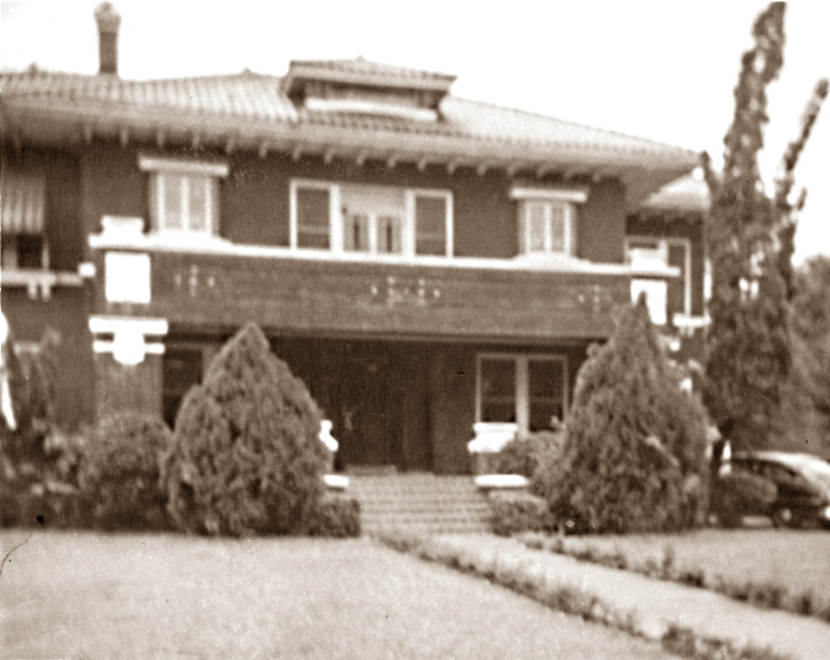
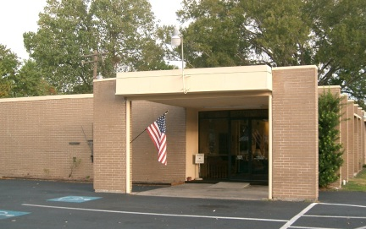
Gulf Coast Club (Cropped to show original 1968 size)
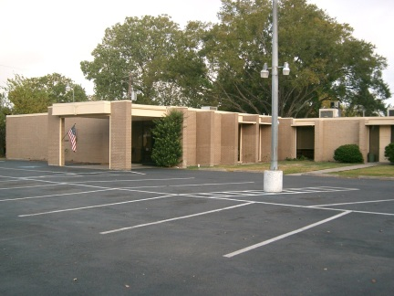
Gulf Coast Club Today
Gulf Coast Club history
Mary Jane C.
(Editor’s note)
Mary Jane is the sole surviving member of the original membership and club historian. Although she is an Al Anon, she is closely associated with the alcoholic side of the program. In 1967, when she could not put up with her husband’s drinking any longer, she opened the phone book at random and saw the name of a high school girl friend she had not talked to in several years. She called her and after passing off a few niceties, she began to talk about her dilemma with her husband, Edwin. Unbeknownst to Mary Jane the friend had joined AA a few years before and talked with Mary Jane several hours about the AA and Al Anon programs. She steered them to AA and Al Anon and they started going to various meetings around Houston. She went to the Gulf Coast Club on its opening day and has remained ever since. At 40 years old, she was the youngest member at the club. While new in the program, she closely watched Edwin at the Montrose Group and still tried to control his behavior, doing such things as demanding he get up from the coffee table and get to a meeting. It was an alcoholic that told her to ease up on him. To this day, she still attends more open AA meetings than Al Anon meetings and celebrates her birthday at an AA meeting.
Without her fund raising, the additions to the Gulf Coast Club would not have been possible. She has been a tireless and diligent steward since 1968. This history of the Gulf Coast Club is taken from her memoirs and personal interviews.
Gulf Coast Club history
Money was especially tight during the early years and many times Fred K. and Mary Jane had to scrounge up money and go downtown to make a payment to keep from having the utilities turned off.
Wayne T. began painting a window at Christmas in 1970. He would paint the “favorite” Christmas card for the season on the plate glass window next to the coffee bar. A gift donation box for a needy family was placed next to the window to brighten their Christmas.

Pete K. "slipped" in 1970 and showed up at a club bar-B-Q drunk. When he went to leave, Mary Jane was terrified for his safety and prayed loudly "Please dear God, let him run off in a ditch." He promptly ran off into the parking lot ditch. The parking lot was full of cars and miraculously he missed them all.

In the early 1970's the AlAteen program was founded by Mary Jane’s daughter, Cissy. The AlAteen program was so active they chartered buses to go to outside events. They held bake sales, car washes and did babysitting to fund their activities. She remained the adult sponsor for several years until she left to go to law school.

After a lengthy card game in 1971, one of the players laid his head on the table, had a heart attack and died. Thinking he was exhausted from the all day card game, no one bothered him until they were ready to fold and put away the card table. He was taken out in the office hallway and administered CPR, which proved futile. The coroner came and pronounced him dead at the scene.
During the early 70's, on two separate occasions, differences in a board meeting broke out into fistfights.

The rear building extension was built in 1973. It was financed through donations and monthly Bar-B-Q's. Mary Jane’s husband, Edwin, was club bar-B-Q cook at the time. Both Mary Jane and Edwin participated extensively in club functions and activities.

In the late 1970's the board gave a new member several hundred dollars from the club roofing fund to purchase roofing repair materials. He promptly vanished from the club, taking the money with him.

In 1978 the Houston Western club split from the Gulf Coast Club. The primary reason was disagreement with board decisions. The Houston Western Club remained active until the 1990’s.

In the 1980’s, Tom G., a chain smoker, caught the club on fire on two different occasions. Both fires were started when he discarded lit cigarettes in the restroom trashcan. The board decided that he would not be allowed on the premises unless escorted by an adult family member.

Bruce S. and several part time volunteers built the back deck in 1983. The idea was conceived by Miller H. and six other club members while dining at the River Bend Country Club. They estimated the cost would be about $7000.00. Miller donated $500.00 and the other six donated $100.00 each to get the project started. Once again, Mary Jane was put in charge of fund raising. At one point, one of the club characters, “Wild Bill”, asked Mary Jane how much she had collected. When she replied “2000.00”, he spouted off and made the brash comment “You will never get $7000.00. I tell you what; I’ll give $1000.00 if you can get $1000.00 from someone else.” After several minutes of heated discussion with Wild Bill, Mary Jane called Pat B. and got the other $1000.00 in less than five minutes. Wild Bill turned beet red and lamented as to what his wife Ellen would say. Mary Jane responded “That’s your problem, give me a check.” After completing the deck, enough money was left to re-carpet the club. A garage sale was held and enough money was raised to buy new couches, tables and lamps. Individual donations were raised to purchase new easy chairs.

In March of 1984, the Lamplighter Club split from the Gulf Coast Club, led by Miller H. and several others. The two primary causes of the split were disagreement with the board of directors and the new furniture selection. It is ironic that Miller was the person that put the club update into motion and that became one of the reasons for leaving. The Lamplighter Club remains active to this day.

In the early 1980’s Bunky B. organized the Gulf Coast Club Choir for Christmas presentations. Practices were started before Thanksgiving each year. The presentations were very professional and consisted of several choir selections and followed up with a Christmas carol sing-along. The choir was recognized citywide and the Christmas party would have 100 or more people present. Bunky continued the choir until the mid-1990’s until she married Ed L. and moved to Wimberley.

In 2002, the club was in dire economic straits and was contemplating selling the property. Mary Jane was in a meeting at the Delta Club and in conversation with Chester G. learned that the KISS NA group was having to relocate and was looking for a new meeting place. She suggested they get in touch with the Gulf Coast Club. A deal was struck and NA became a part of the Gulf Coast Club.

In 2004, the Marcus oil and chemical plant across the street from the club had an explosion and the club was severely damaged. The initial ball of fire went over the top of the club, followed immediately by the concussion blast. All of the plate glass windows in the club were blown out, as well as both the front and back doors, inside ceilings were demolished and considerable disarray of the property was done. All of the windows in the custodian’s house were also blown out and the garage was lifted from its foundation and moved back about a foot. Don and Carol A., Emil and Sandie B., Bill F., Tamara B., James T. and Juan V. were in the club when the plant exploded. They were battered and bruised and Sandie was cut on her shoulder and required stitches. Tamara’s son was in her car but luckily was uninjured. Bruce S., Don A. and a volunteer crew immediately began boarding up and bracing the structure. Meetings were resumed a week later.

Over the years, the club has had an active social life. There has been a multitude of weddings, funeral memorials, special events and theme parties at the club. Among the favorite activities were:

Volleyball and horseshoes
Hawaiian luau
Square dancing
Dancing and dancing lessons
Gong show
Fashion show
Game night
Las Vegas night
St. Patrick’s Day liars contest
Dominoes, gin rummy and bridge games
Thanksgiving and Christmas dinner (including Santa Claus distributing gifts for the children)
New Year’s Eve live band dance
Easter egg hunt
The Gulf Coast Campers
Monthly covered dish meals
Bar-B-Q’s
Fish fries
Chicken fries
Turkey fries

